SDA PROJECT REPORT

STOCK PORTIFOLIO DATASET ANALYSIS

Group members:

R. Navya Sai

B. Devi Neeharika

ABSTRACT:

The main goal of this project is to extract the maximum knowledge from stock portifolio dataset. We apply linear regression model for this dataset and check all the assumptions here.

METHODOLOGY:

1. Loading the dataset

2. Check for Null Values.

3. Check for normality of data.

4. Influential points detection.

5. Removal of influential points.

6. Check for correlation between dependent variables (Feature selection)

7. Splitting of data into train and test data and apply regression model.

8. Test of hypothesis based on P value (feature selection).

9. Test of assumptions

a. Linearity

b. Homoscedasticity

c. Normality of errors

d. Uncorrelated errors.

10. Goodness of test.

DESCRIPTION OF DATA:

**Attribute Information**:

The inputs are the weights of the stock-picking concepts as follows

X1=the weight of the Large B/P concept

X2=the weight of the Large ROE concept

X3=the weight of the Large S/P concept

X4=the weight of the Large Return Rate in the last quarter concept

X5=the weight of the Large Market Value concept

X6=the weight of the Small systematic Risk concept

The outputs are the investment performance indicators as follows

Y1=Annual Return

Y2=Excess Return

Y3=Systematic Risk

Y4=Total Risk

Y5=Abs. Win Rate

Y6=Rel. Win Rate

ANALYSIS:

Sample data:

|  | **Large B/P** | **Large ROE** | **Large S/P** | **Large Return Rate in the last quarter** | **Large Market Value** | **Small systematic Risk** | **Annual Return** | **Excess Return** | **Systematic Risk** | **Total Risk** | **Abs. Win Rate** | **Rel. Win Rate** |
| --- | --- | --- | --- | --- | --- | --- | --- | --- | --- | --- | --- | --- |
| **0** | 1.0 | 0.0 | 0.0 | 0.0 | 0.0 | 0.0 | 0.531875 | 0.478116 | 0.738015 | 0.800000 | 0.52 | 0.411765 |
| **1** | 0.0 | 1.0 | 0.0 | 0.0 | 0.0 | 0.0 | 0.549712 | 0.487595 | 0.571579 | 0.412231 | 0.52 | 0.764706 |
| **2** | 0.0 | 0.0 | 1.0 | 0.0 | 0.0 | 0.0 | 0.692625 | 0.629895 | 0.703051 | 0.756879 | 0.44 | 0.376471 |
| **3** | 0.0 | 0.0 | 0.0 | 1.0 | 0.0 | 0.0 | 0.324351 | 0.255634 | 0.800000 | 0.756046 | 0.36 | 0.270588 |
| **4** | 0.0 | 0.0 | 0.0 | 0.0 | 1.0 | 0.0 | 0.326615 | 0.306501 | 0.432452 | 0.209289 | 0.72 | 0.447059 |

Summary of data:

|  | **Large B/P** | **Large ROE** | **Large S/P** | **Large Return Rate in the last quarter** | **Large Market Value** | **Small systematic Risk** | **Annual Return** | **Excess Return** | **Systematic Risk** | **Total Risk** | **Abs. Win Rate** | **Rel. Win Rate** |
| --- | --- | --- | --- | --- | --- | --- | --- | --- | --- | --- | --- | --- |
| **count** | 63.000000 | 63.000000 | 63.000000 | 63.000000 | 63.000000 | 63.000000 | 63.000000 | 63.000000 | 63.000000 | 63.000000 | 63.000000 | 63.000000 |
| **mean** | 0.166619 | 0.166619 | 0.166619 | 0.166619 | 0.166619 | 0.166619 | 0.580151 | 0.576170 | 0.426494 | 0.391749 | 0.566984 | 0.547899 |
| **variance** | 0.199304 | 0.199304 | 0.199304 | 0.199304 | 0.199304 | 0.199304 | 0.133358 | 0.137047 | 0.118178 | 0.136653 | 0.112803 | 0.159468 |
| **min** | 0.000000 | 0.000000 | 0.000000 | 0.000000 | 0.000000 | 0.000000 | 0.200000 | 0.200000 | 0.200000 | 0.200000 | 0.200000 | 0.200000 |
| **25%** | 0.000000 | 0.000000 | 0.000000 | 0.000000 | 0.000000 | 0.000000 | 0.525811 | 0.519093 | 0.358600 | 0.297324 | 0.520000 | 0.411765 |
| **50%** | 0.167000 | 0.167000 | 0.167000 | 0.167000 | 0.167000 | 0.167000 | 0.598516 | 0.587148 | 0.403418 | 0.368958 | 0.560000 | 0.552941 |
| **75%** | 0.291500 | 0.291500 | 0.291500 | 0.291500 | 0.291500 | 0.291500 | 0.679636 | 0.669294 | 0.470571 | 0.457749 | 0.640000 | 0.694118 |
| **max** | 1.000000 | 1.000000 | 1.000000 | 1.000000 | 1.000000 | 1.000000 | 0.800000 | 0.800000 | 0.800000 | 0.800000 | 0.800000 | 0.800000 |

Null values:

False

Normality of data:

**Large B/P**

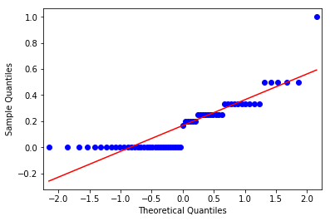

**Large ROE**



**Large S/P**



**Large Return Rate in the last quarter concept**



**Large Market Value concept**



**Small systematic Risk concept**



Influential points:

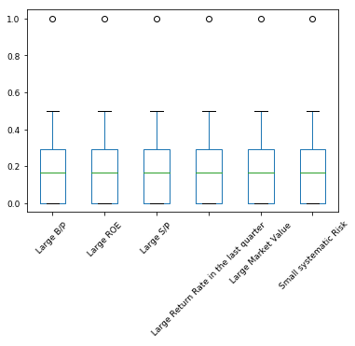

After removing influential points we left with 57 rows.

Data visualization:

Correlation plot:

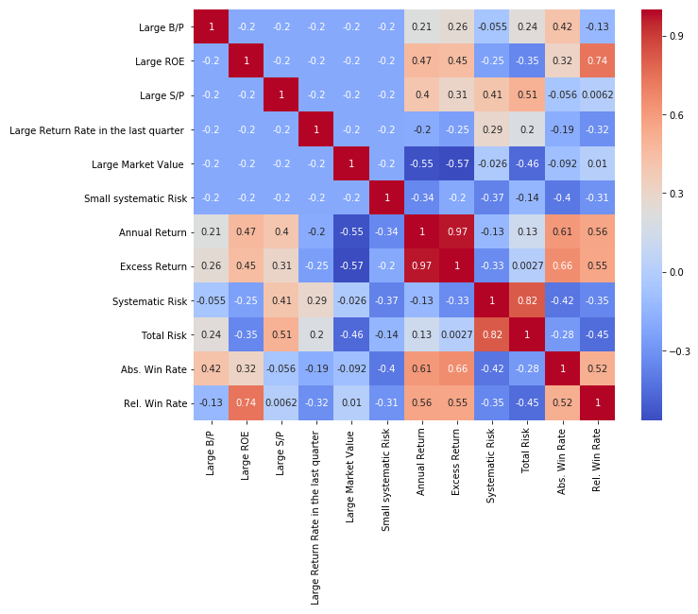

Correlation plot between the predictors and normalized response variables for the All Period dataset.

Build a regression model:

Linear regression:

Model for **Annual Return** evaluation parameter

The linear model is: Y = -12.438 + 13.148*large b/p + 13.355*large ROE + 13.286*large s/p+ 12.912*large return rates+ 12.719*large market sales+ 12.817*small system risk

**Variance score**: 0.7019488999882291

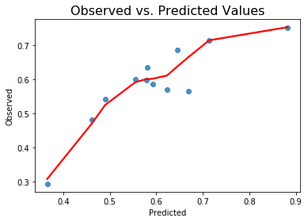

Model for **Excess Return** evaluation parameter

The linear model is: Y = -16.664 + 17.401*large b/p + 17.568*large ROE + 17.455*large s/p+ 17.114*large return rates+ 16.927*large market sales+ 17.128*small system risk

**Variance score**: 0.6717835969280928

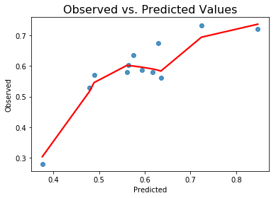

Model for **Systematic Risk** evaluation parameter

The linear model is: Y = 14.279 + -13.893*large b/p + -13.983*large ROE + -13.669*large s/p+ -13.757*large return rates+ -13.875*large market sales+ -14.056*small system risk

**Variance score**: 0.08145662584081781

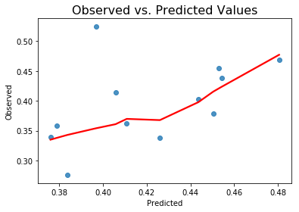

Model for **Total Risk** evaluation parameter

The linear model is: Y = 7.0886 + -6.5722*large b/p + -6.8841*large ROE + -6.431*large s/p+ -6.6196*large return rates+ -6.9572*large market sales+ -6.8111*small system risk

**Variance score**: 0.30663192303226283

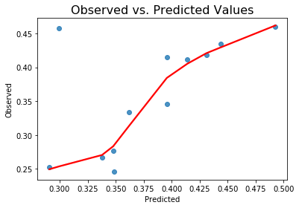

Model for **Abs. Win Rate** evaluation parameter

The linear model is: Y = -20.205 + 20.978*large b/p + 20.954*large ROE + 20.767*large s/p+ 20.718*large return rates+ 20.75*large market sales+ 20.591*small system risk

**Variance score**: 0.5045284905611849

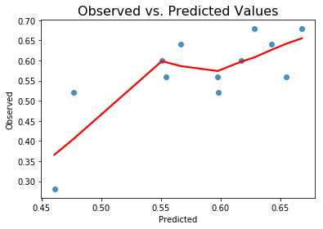

Model for **Rel. Win Rate** evaluation parameter

The linear model is: Y = -46.851 + 47.324*large b/p + 47.982*large ROE + 47.441*large s/p+ 47.204*large return rates+ 47.448*large market sales+ 47.194*small system risk

**Variance score**: 0.6624426054758186

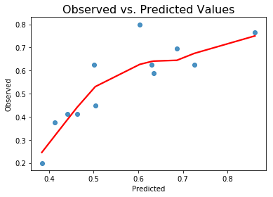

Ordinary least squares (OLS):

* Ordinary least squares (OLS) regression is a [statistical method](https://www.encyclopedia.com/earth-and-environment/ecology-and-environmentalism/environmental-studies/statistical-method) of analysis that estimates the relationship between one or more independent variables and a dependent variable; the method estimates the relationship by minimizing the sum of the squares in the difference between the observed and predicted value of the dependent variable configured as a straight line

**OLS summary as follows**:

=======================================================================================

Dep. Variable: Annual Return R-squared (uncentered): 0.990

Model: OLS Adj. R-squared (uncentered): 0.988

Method: Least Squares F-statistic: 644.1

Date: Thu, 28 Nov 2019 Prob (F-statistic): 2.13e-37

Time: 10:53:22 Log-Likelihood: 62.057

No. Observations: 45 AIC: -112.1

Df Residuals: 39 BIC: -101.3

Df Model: 6

Covariance Type: nonrobust

===========================================================================================================

coef std err t P>|t| [0.025 0.975]

-----------------------------------------------------------------------------------------------------------

Large B/P 0.7031 0.049 14.352 0.000 0.604 0.802

Large ROE 0.9135 0.050 18.351 0.000 0.813 1.014

Large S/P 0.8442 0.050 16.978 0.000 0.744 0.945

Large Return Rate in the last quarter 0.4679 0.049 9.498 0.000 0.368 0.567

Large Market Value 0.2811 0.048 5.896 0.000 0.185 0.377

Small systematic Risk 0.3766 0.047 7.985 0.000 0.281 0.472

==============================================================================

Omnibus: 3.579 Durbin-Watson: 2.099

Prob(Omnibus): 0.167 Jarque-Bera (JB): 3.382

Skew: -0.624 Prob(JB): 0.184

Kurtosis: 2.503 Cond. No. 2.53

==============================================================================

Warnings:

[1] Standard Errors assume that the covariance matrix of the errors is correctly specified.

OLS Regression Results

=======================================================================================

Dep. Variable: Excess Return R-squared (uncentered): 0.986

Model: OLS Adj. R-squared (uncentered): 0.984

Method: Least Squares F-statistic: 473.7

Date: Thu, 28 Nov 2019 Prob (F-statistic): 7.88e-35

Time: 10:53:22 Log-Likelihood: 55.222

No. Observations: 45 AIC: -98.44

Df Residuals: 39 BIC: -87.60

Df Model: 6

Covariance Type: nonrobust

===========================================================================================================

coef std err t P>|t| [0.025 0.975]

-----------------------------------------------------------------------------------------------------------

Large B/P 0.7275 0.057 12.758 0.000 0.612 0.843

Large ROE 0.8993 0.058 15.521 0.000 0.782 1.017

Large S/P 0.7855 0.058 13.570 0.000 0.668 0.903

Large Return Rate in the last quarter 0.4423 0.057 7.714 0.000 0.326 0.558

Large Market Value 0.2629 0.055 4.737 0.000 0.151 0.375

Small systematic Risk 0.4608 0.055 8.394 0.000 0.350 0.572

==============================================================================

Omnibus: 2.634 Durbin-Watson: 2.016

Prob(Omnibus): 0.268 Jarque-Bera (JB): 2.378

Skew: -0.475 Prob(JB): 0.304

Kurtosis: 2.395 Cond. No. 2.53

==============================================================================

Warnings:

[1] Standard Errors assume that the covariance matrix of the errors is correctly specified.

OLS Regression Results

=======================================================================================

Dep. Variable: Systematic Risk R-squared (uncentered): 0.966

Model: OLS Adj. R-squared (uncentered): 0.961

Method: Least Squares F-statistic: 187.0

Date: Thu, 28 Nov 2019 Prob (F-statistic): 3.78e-27

Time: 10:53:22 Log-Likelihood: 51.486

No. Observations: 45 AIC: -90.97

Df Residuals: 39 BIC: -80.13

Df Model: 6

Covariance Type: nonrobust

===========================================================================================================

coef std err t P>|t| [0.025 0.975]

-----------------------------------------------------------------------------------------------------------

Large B/P 0.3944 0.062 6.365 0.000 0.269 0.520

Large ROE 0.2997 0.063 4.761 0.000 0.172 0.427

Large S/P 0.6145 0.063 9.771 0.000 0.487 0.742

Large Return Rate in the last quarter 0.5289 0.062 8.490 0.000 0.403 0.655

Large Market Value 0.4037 0.060 6.695 0.000 0.282 0.526

Small systematic Risk 0.2259 0.060 3.788 0.001 0.105 0.347

==============================================================================

Omnibus: 2.416 Durbin-Watson: 2.020

Prob(Omnibus): 0.299 Jarque-Bera (JB): 1.886

Skew: 0.502 Prob(JB): 0.389

Kurtosis: 3.005 Cond. No. 2.53

==============================================================================

Warnings:

[1] Standard Errors assume that the covariance matrix of the errors is correctly specified.

OLS Regression Results

=======================================================================================

Dep. Variable: Total Risk R-squared (uncentered): 0.967

Model: OLS Adj. R-squared (uncentered): 0.962

Method: Least Squares F-statistic: 192.4

Date: Thu, 28 Nov 2019 Prob (F-statistic): 2.22e-27

Time: 10:53:22 Log-Likelihood: 54.943

No. Observations: 45 AIC: -97.89

Df Residuals: 39 BIC: -87.05

Df Model: 6

Covariance Type: nonrobust

===========================================================================================================

coef std err t P>|t| [0.025 0.975]

-----------------------------------------------------------------------------------------------------------

Large B/P 0.5203 0.057 9.068 0.000 0.404 0.636

Large ROE 0.2063 0.058 3.539 0.001 0.088 0.324

Large S/P 0.6599 0.058 11.330 0.000 0.542 0.778

Large Return Rate in the last quarter 0.4725 0.058 8.190 0.000 0.356 0.589

Large Market Value 0.1313 0.056 2.351 0.024 0.018 0.244

Small systematic Risk 0.2791 0.055 5.052 0.000 0.167 0.391

==============================================================================

Omnibus: 5.861 Durbin-Watson: 2.038

Prob(Omnibus): 0.053 Jarque-Bera (JB): 4.851

Skew: 0.781 Prob(JB): 0.0884

Kurtosis: 3.381 Cond. No. 2.53

==============================================================================

Warnings:

[1] Standard Errors assume that the covariance matrix of the errors is correctly specified.

OLS Regression Results

=======================================================================================

Dep. Variable: Abs. Win Rate R-squared (uncentered): 0.983

Model: OLS Adj. R-squared (uncentered): 0.980

Method: Least Squares F-statistic: 372.4

Date: Thu, 28 Nov 2019 Prob (F-statistic): 7.94e-33

Time: 10:53:22 Log-Likelihood: 51.463

No. Observations: 45 AIC: -90.93

Df Residuals: 39 BIC: -80.09

Df Model: 6

Covariance Type: nonrobust

===========================================================================================================

coef std err t P>|t| [0.025 0.975]

-----------------------------------------------------------------------------------------------------------

Large B/P 0.7621 0.062 12.294 0.000 0.637 0.887

Large ROE 0.7432 0.063 11.798 0.000 0.616 0.871

Large S/P 0.5549 0.063 8.818 0.000 0.428 0.682

Large Return Rate in the last quarter 0.5027 0.062 8.065 0.000 0.377 0.629

Large Market Value 0.5454 0.060 9.042 0.000 0.423 0.667

Small systematic Risk 0.3820 0.060 6.400 0.000 0.261 0.503

==============================================================================

Omnibus: 0.405 Durbin-Watson: 1.902

Prob(Omnibus): 0.817 Jarque-Bera (JB): 0.067

Skew: 0.082 Prob(JB): 0.967

Kurtosis: 3.095 Cond. No. 2.53

==============================================================================

Warnings:

[1] Standard Errors assume that the covariance matrix of the errors is correctly specified.

OLS Regression Results

=======================================================================================

Dep. Variable: Rel. Win Rate R-squared (uncentered): 0.979

Model: OLS Adj. R-squared (uncentered): 0.975

Method: Least Squares F-statistic: 297.5

Date: Thu, 28 Nov 2019 Prob (F-statistic): 5.76e-31

Time: 10:53:22 Log-Likelihood: 46.904

No. Observations: 45 AIC: -81.81

Df Residuals: 39 BIC: -70.97

Df Model: 6

Covariance Type: nonrobust

===========================================================================================================

coef std err t P>|t| [0.025 0.975]

-----------------------------------------------------------------------------------------------------------

Large B/P 0.4473 0.069 6.521 0.000 0.309 0.586

Large ROE 1.1190 0.070 16.053 0.000 0.978 1.260

Large S/P 0.5754 0.070 8.263 0.000 0.435 0.716

Large Return Rate in the last quarter 0.3307 0.069 4.794 0.000 0.191 0.470

Large Market Value 0.5973 0.067 8.948 0.000 0.462 0.732

Small systematic Risk 0.3330 0.066 5.042 0.000 0.199 0.467

==============================================================================

Omnibus: 2.566 Durbin-Watson: 1.945

Prob(Omnibus): 0.277 Jarque-Bera (JB): 2.134

Skew: 0.532 Prob(JB): 0.344

Kurtosis: 2.920 Cond. No. 2.53

==============================================================================

Warnings:

[1] Standard Errors assume that the covariance matrix of the errors is correctly specified.

* If **p> 0.05** , we fail to reject null hypothesis otherwise we reject null hypothesis.
* After observing p values if **p value > 0.05** we assume that features are less contributed to evaluation parameters. After observing P values in the above summary all are below 0.05 so we can assume that all are important for predicting evaluation parameters.

Test of assumptions:

LINEARITY:

**Annual return**

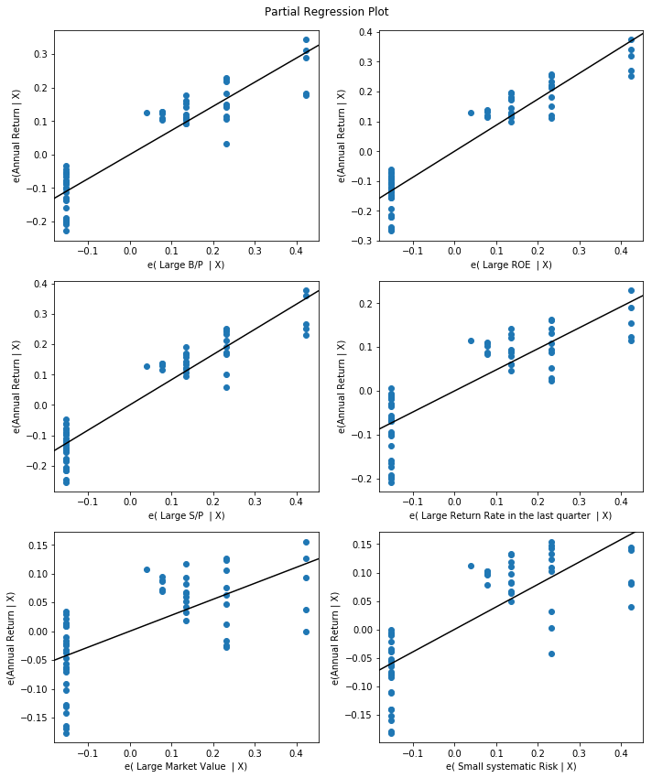

**Excess return**

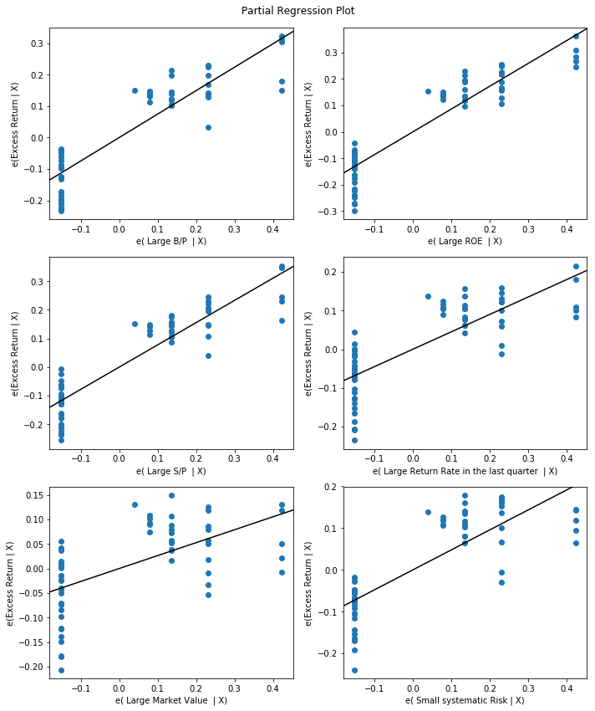

**Systematic risk**

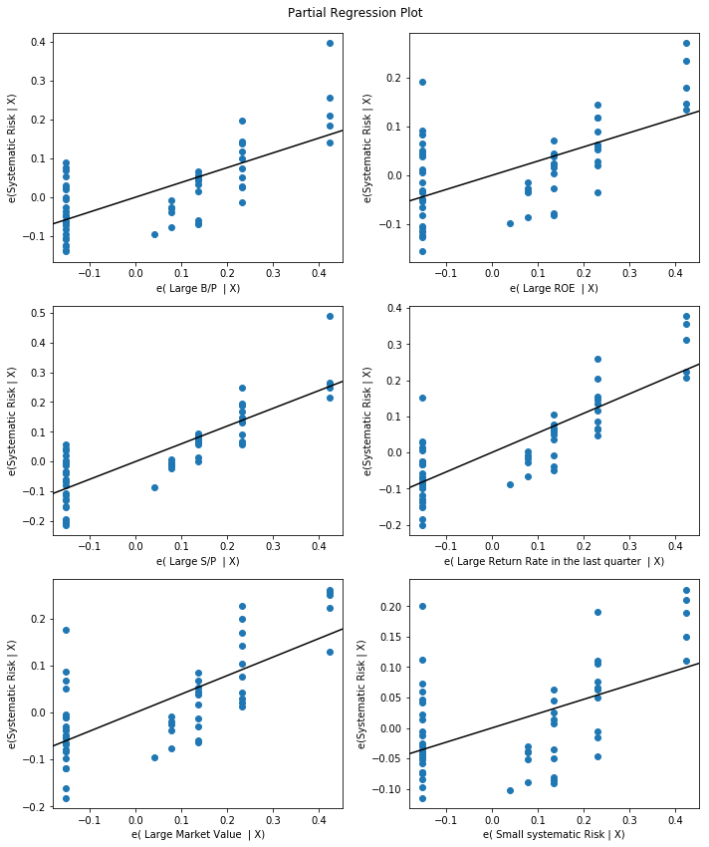

**Total risk**

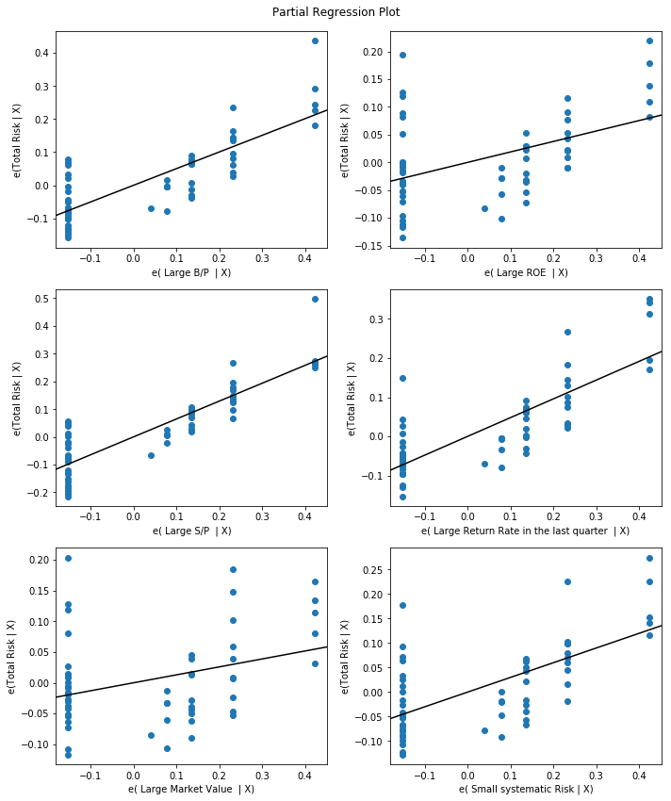

**Abs. win rate**

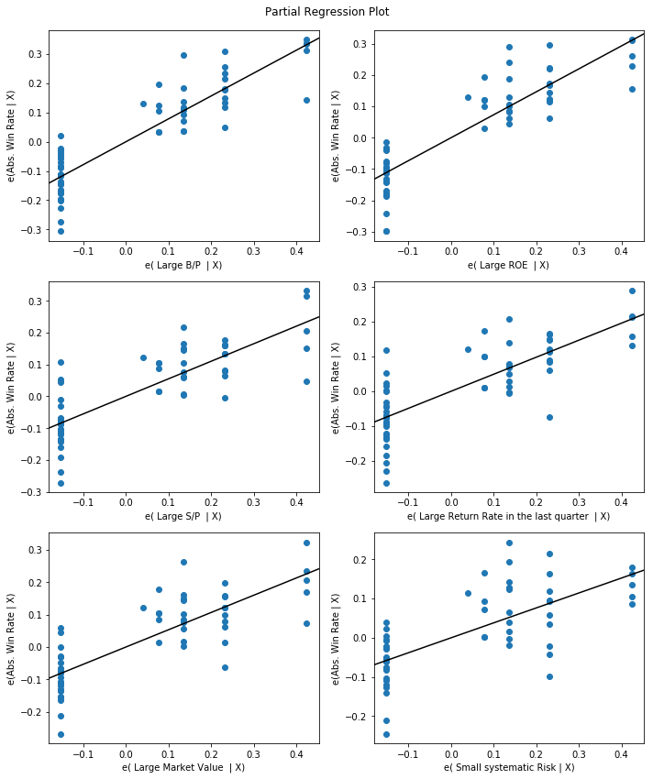

**Rel. win rate**

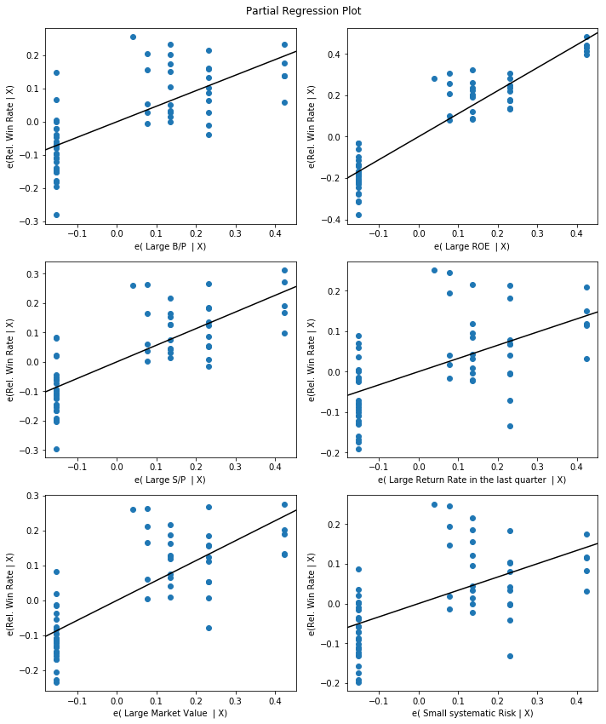

If we observe carefully, all the partial residual plots between the independent variable and dependent variable are linear. Linearity condition is satisfied.

HOMOSCEDASTICITY:

* To check homoscedasticity, we plot the residuals vs predicted values/fitted values.
* If we see any kind of funnel shape, we can say that there is heteroscedasticity.

**Annual return**

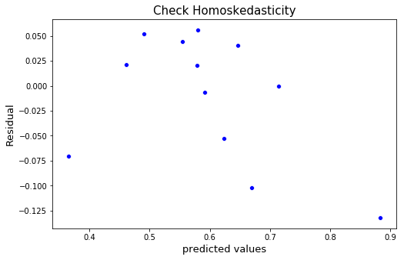

**Excess return**

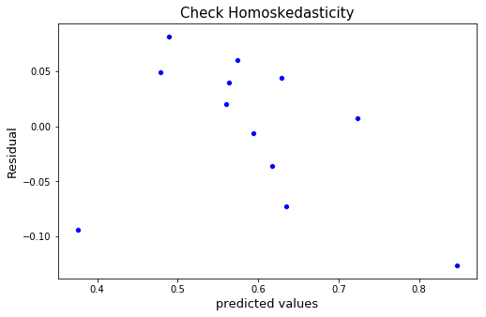

**Systematic risk**

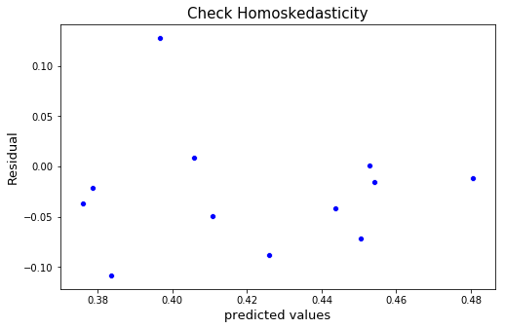

**Total risk**

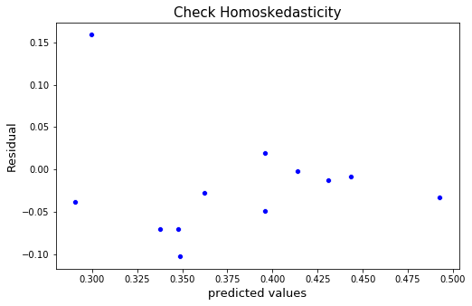

**Abs. win rate**

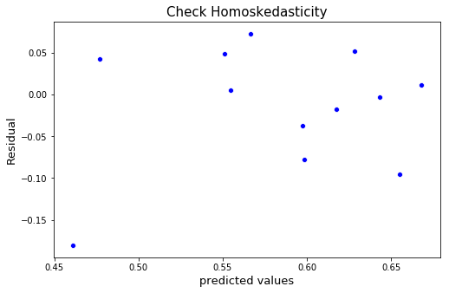

**Rel. win rate**

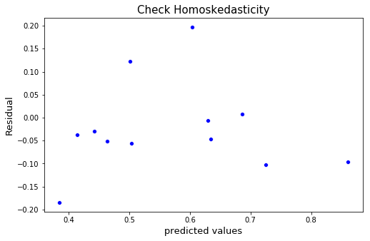

* The points are random. which confirms that there is homoscedasticity.
* It means that the variance of Y across all X is same.  - We can conclude that, Homoscedasticity condition hold in this case.

Uncorrelated errors

**Annual return**

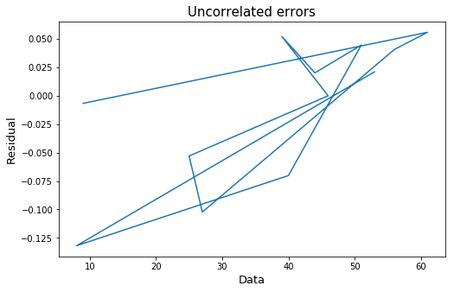

**Excess return**

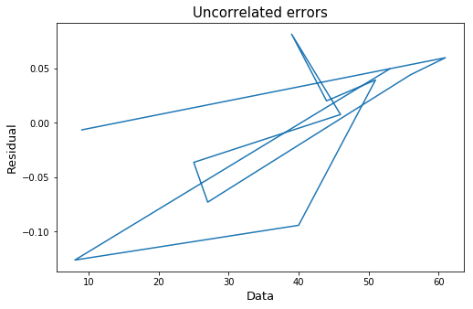

**Systematic risk**

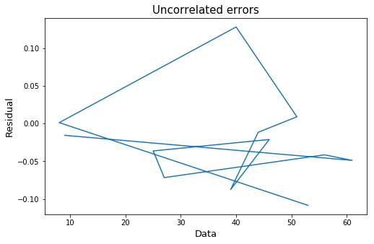

**Total risk**

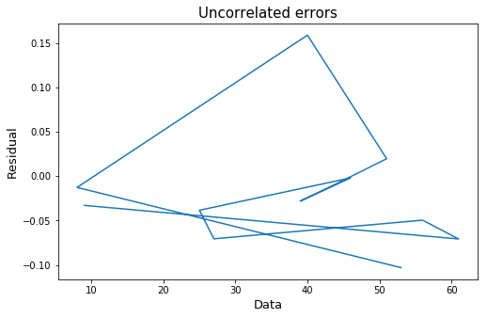

**Abs. win rate**

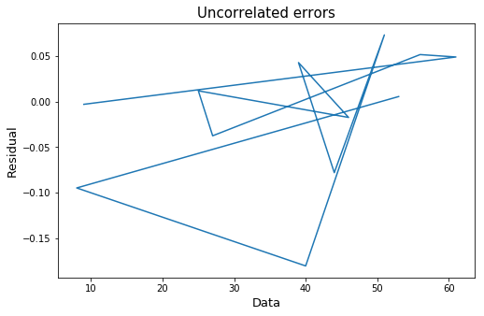

**Rel. win rate**

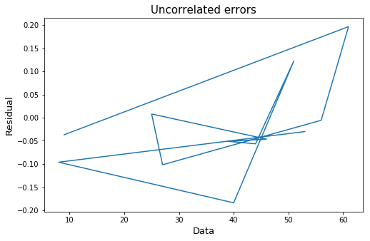

* If we observe, there exists correlation/pattern between errors.
* We can also check this condition using the Durbin-Watson test:

If DW = 2, then there is no correlation.

If DW < 2, then the errors are positively correlated.

If DW > 2, then the errors are negatively correlated.

* + - * If we perform Durbin-Watson test, the values of DW are
* 1.6215799780769184
* 1.6819424442764341
* 1.1953060659793757
* 1.215215373547569
* 2.2147484787943914
* 2.1946702508706504

* + - * According to the test, we can say that for first 4 evaluation parameters errors are positively correlated and remaining are negatively correlated.
      * However, this is a point estimate for perfect un- correlation of errors (DW=2). So, we won’t get DW as 2 on real data. If it around 2, then we can conclude that the errors are uncorrelated.

Normality of error terms:

* This can be checked by plotting probability-probability plot (p-p plot) or Quantile-Quantile plot(Q-Q plot).

**Annual return**

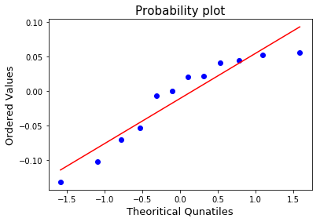

**Excess return**

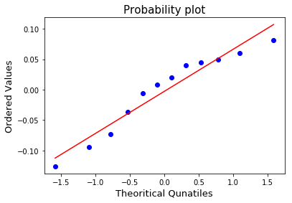

**Systematic risk**

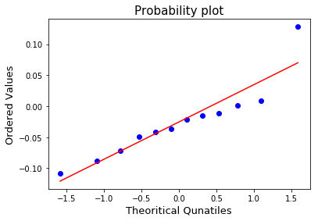

**Total risk**

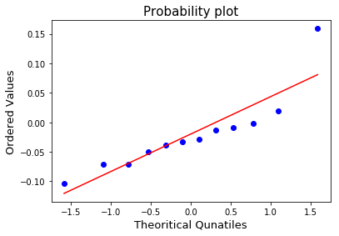

**Abs. win rate**

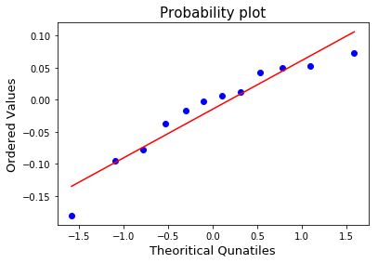

**Rel. win rate**

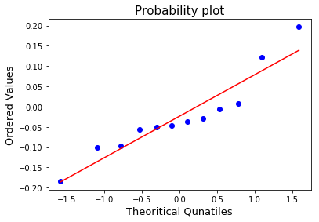

* + If we observe the above plots, we can conclude that the errors are following a Normal distribution, because the plot shows the fluctuation around the line and there is not much deviation. The graphs are linear.

RESULTS:

R-square values of all evaluation parameters w.r.t models

|  |  |  |  |  |  |  |
| --- | --- | --- | --- | --- | --- | --- |
| Model | Annual return | Excess return | Systematic  risk | Total  risk | Absolute win rate | Rel.win rate |
| Linear regression | 0.701 | 0.671 | 0.081 | 0.306 | 0.504 | 0.662 |
| svm | 0.746 | 0.688 | 0.190 | 0.226 | 0.296 | 0.514 |
| Linear regression ridge | 0.682 | 0.625 | 0.103 | 0.297 | 0.354 | 0.4795 |
| Linear regression lasso | -0.011 | -0.007 | -0.034 | -0.05 | -0.010 | -0.011 |
| Decision tree | 0.05 | -0.088 | -1.272 | 0.125 | 0.476 | 0.580 |